**Rust is a multi-paradigm, general-purpose programming language that emphasizes performance, type safety, and concurrency. Rust's borrow checker and type safety are two key features that provide significant advantages for safety in Rust programming.**

**1.Borrow checker:**

**The borrow checker is core component of Rust's ownership system, which has been designed to prevent common programming errors such as data races, use-after-free, and null pointer dereferences. It implements strict rules on how references and ownership are handled, ensuring memory safety without any need of garbage collector.**

1. Ownership Model: Rust enforces a strict ownership model, where every value in Rust has a unique owner at any instant of time. When a value goes out of scope, its resources are automatically deallocated which eliminates the possibility of memory leaks.

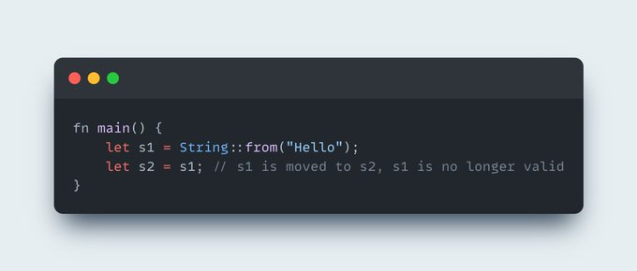

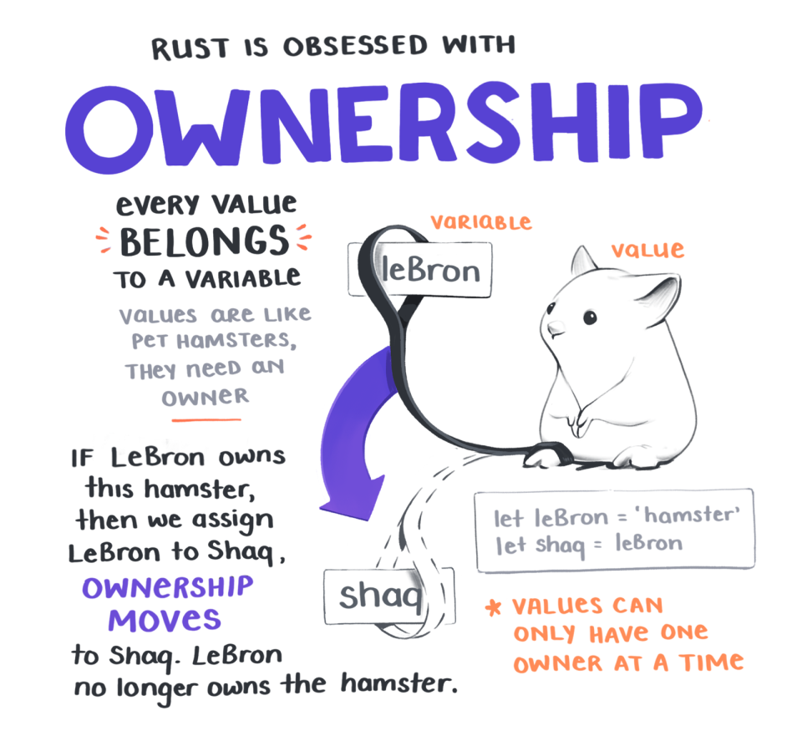

1. Ownership Transfer: Rust permits transfer of ownership between variables through moves. When a value is moved, the original variable can no longer access it, preventing data races or use-after-free bugs.

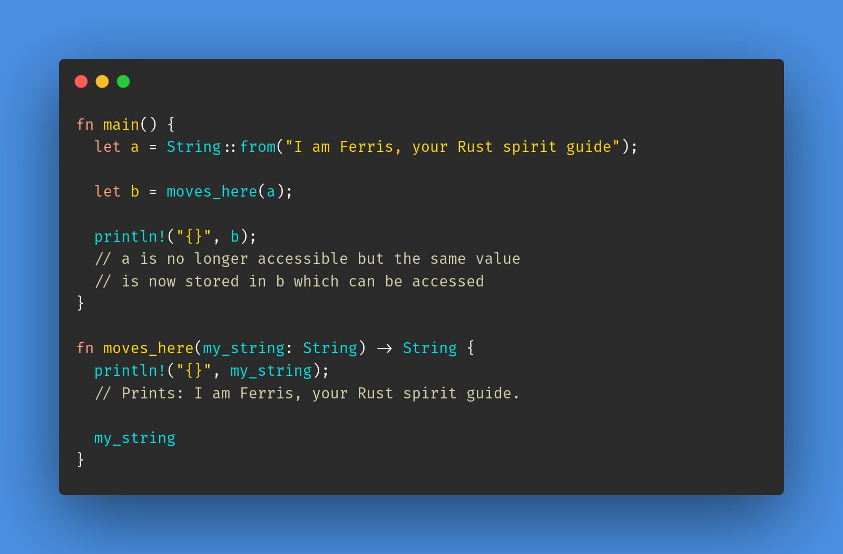

1. Borrowing and References: Rust permits borrowing of values using references. There are two types of references in Rust: immutable references (&T) and mutable references (&mut T). The borrow checker implements strict rules on how references can be used, preventing multiple mutable references to the same value, which could lead to data races.

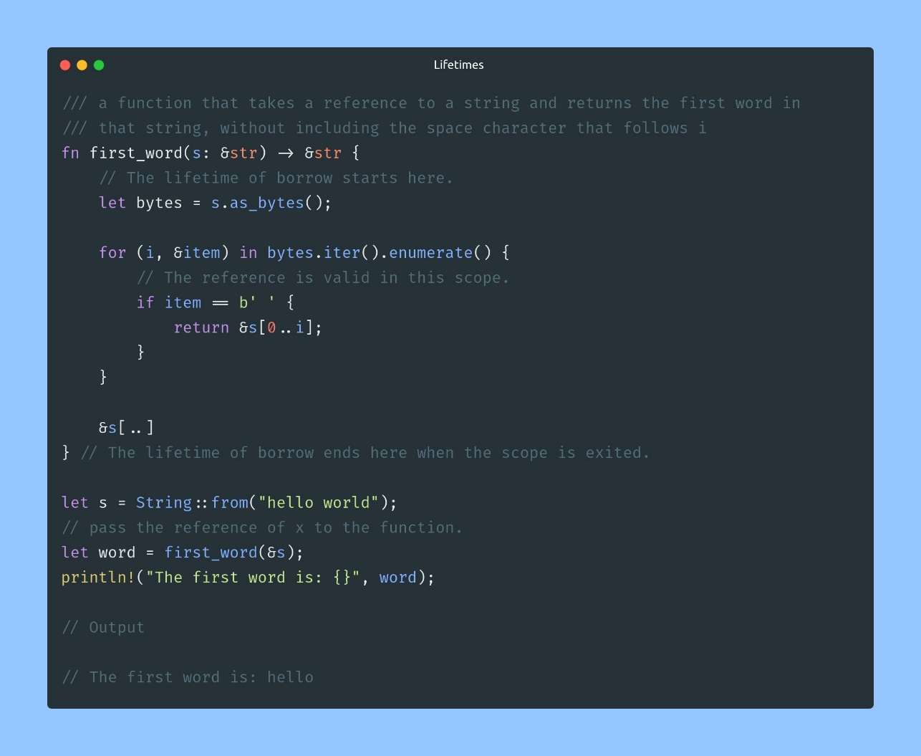

1. Lifetimes: Rust employs the concept of lifetimes to ensure that references are valid throughout their usage. Lifetimes specify the duration for which a reference is valid, and the borrow checker statically analyses the code to ensure that references don't outlive the values they refer to.

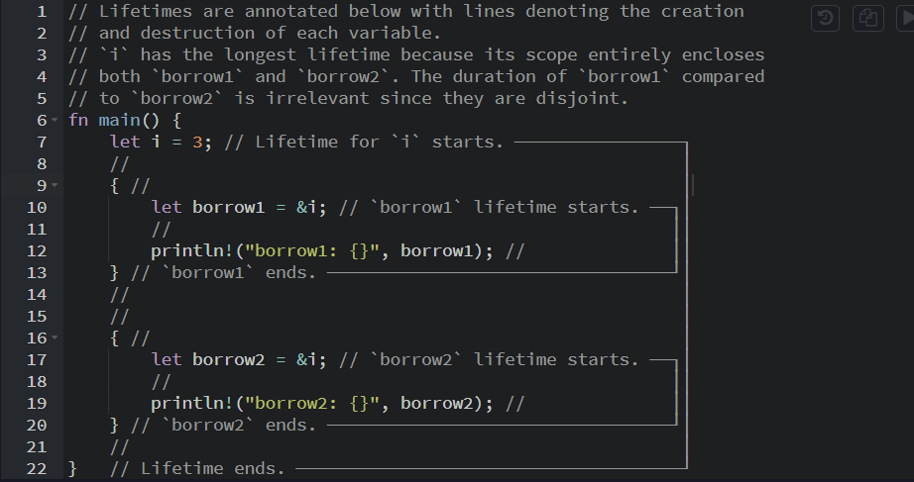

Rust's borrow checker provides significant advantages for safety by preventing data races, use-after-free bugs, and dangling pointers. It ensures memory safety, eliminates common memory-related errors, and enables automatic memory deallocation. By implementing strict ownership and borrowing rules, the borrow checker ensures that programs are free from certain classes of bugs and vulnerabilities, resulting in safer and more reliable software.



**2. Type Safety:**

**Rust is a statically-typed language that provides strong type safety guarantees. Type safety ensures that operations on values are performed only if they are compatible, preventing a wide range of runtime errors.**

1. Null Safety: Rust's type system eliminates the possibility of null pointer dereferences, which is a common source of crashes and bugs in other languages. Rust distinguishes between nullable and non-nullable types, and the compiler enforces strict checks to ensure that null values are not accidentally dereferenced.
2. Memory Safety: Rust guarantees memory safety by preventing buffer overflows, out-of-bounds accesses, and other memory-related errors. Rust's array bounds checking and string handling, for example, ensure that operations on collections are safe and cannot cause memory corruption or undefined behaviour.

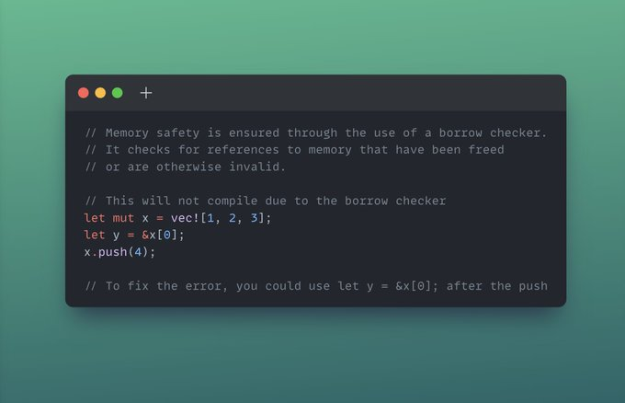

1. Compiler-Verified Correctness: Rust's type system enables powerful static analysis by the compiler. It checks that variables are used according to their declared types, catches type-related errors at compile-time, and ensures that all required operations and methods are correctly implemented. This results in increased confidence in the correctness of the program before it even runs.
2. Code Reusability and Abstraction: Rust's type system, combined with traits and generics, allows for code reusability and abstraction without compromising type safety. Traits ensure that required behaviour is defined for types, while generics enable writing generic code that can operate on different types without sacrificing type checking.
3. Pattern Matching: Rust's pattern matching feature enhances type safety by ensuring that all possible cases are handled exhaustively. This reduces the chances of missing or incomplete handling of different input patterns, improving program correctness and robustness.

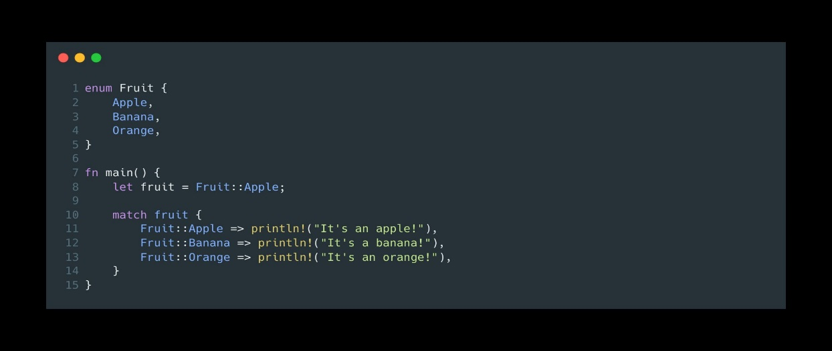

Rust's type safety provides significant advantages for safety by eliminating null pointer errors, ensuring memory safety, enforcing type compatibility, promoting correctness through compiler-verified analysis, enabling code reusability and abstraction, and facilitating exhaustive pattern matching. These features make Rust code less prone to runtime errors, improve program safety, and enhance developer productivity by catching many potential issues at compile-time.

